**MANUAL TEST PLAN**

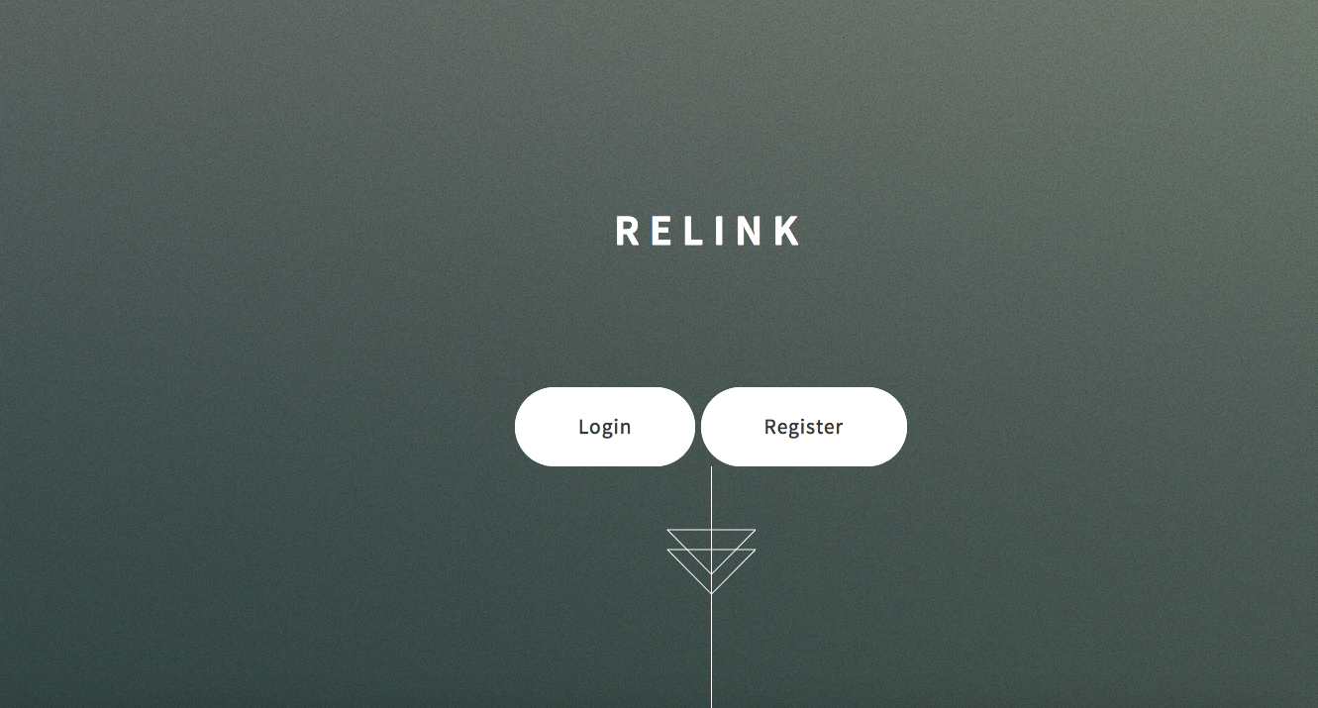

Once Relink is opened up, this is how the landing page looks. There should be two buttons. On should be to login and one should be to register.

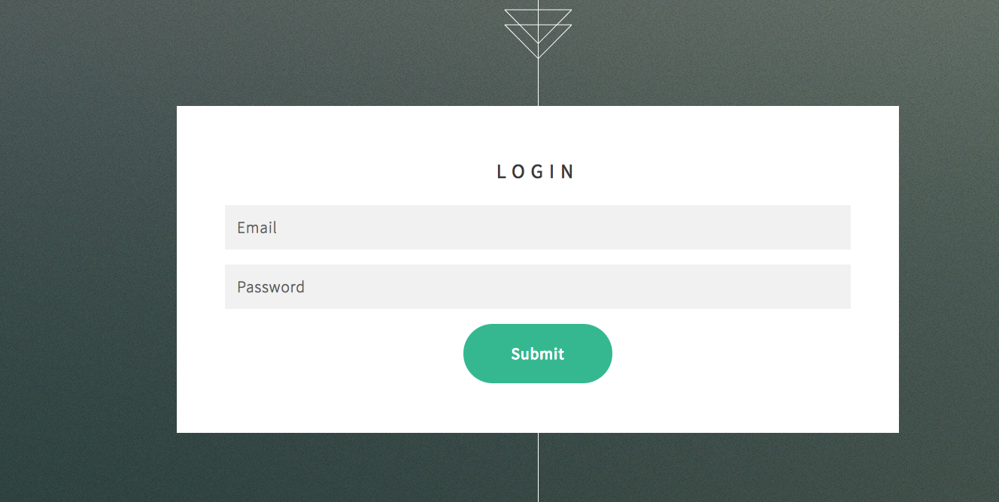

When login button is clicked, this login page that should show up.

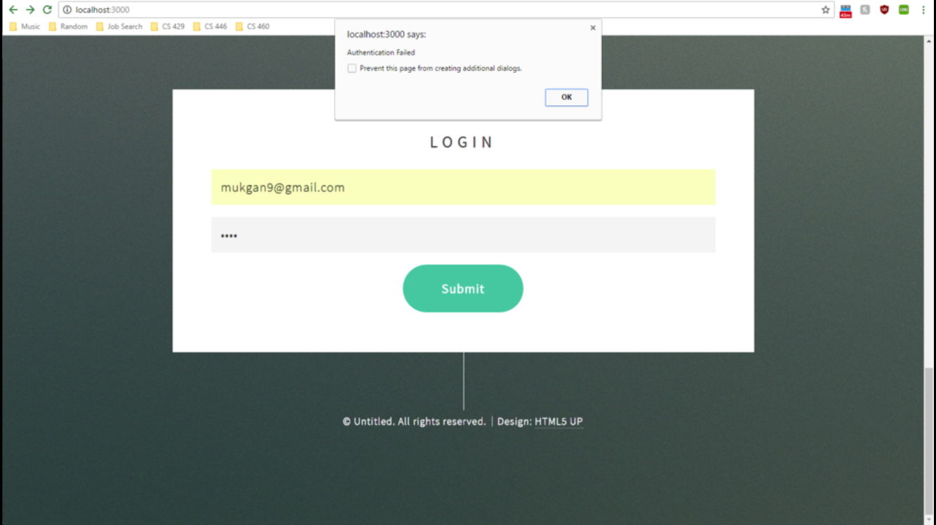

If someone enters in credentials that do not exist in the database while trying to log in, a pop up box should appear notifying the user that the authentication failed.

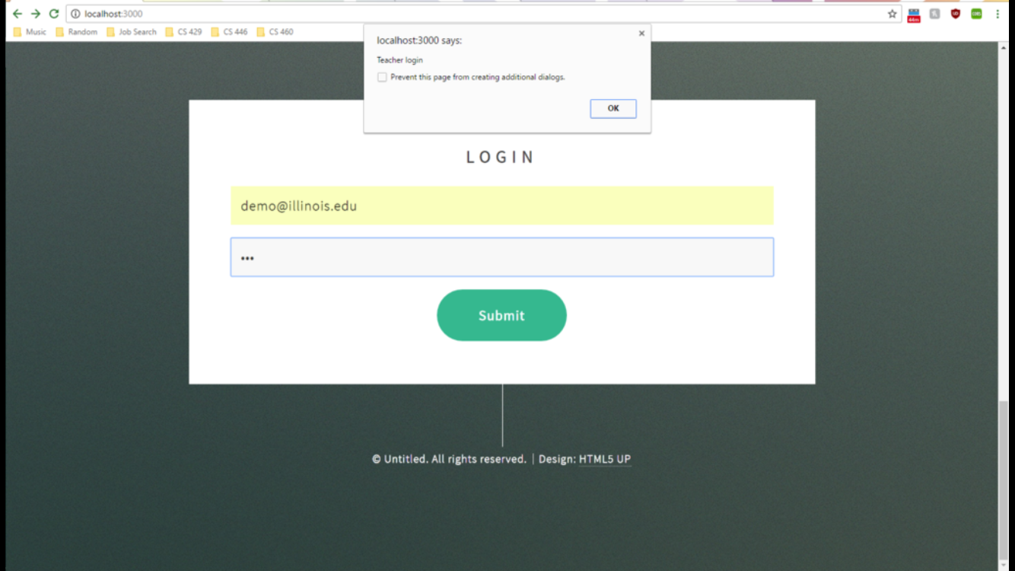

If the user logs in with credentials that were initially registered as a student, for now, a pop up box should appear notifying the user that he/she is a student.



If someone logs in with credentials that were initially registered as an instructor, for now, a pop up box should appear notifying the user that he/she is an instructor.

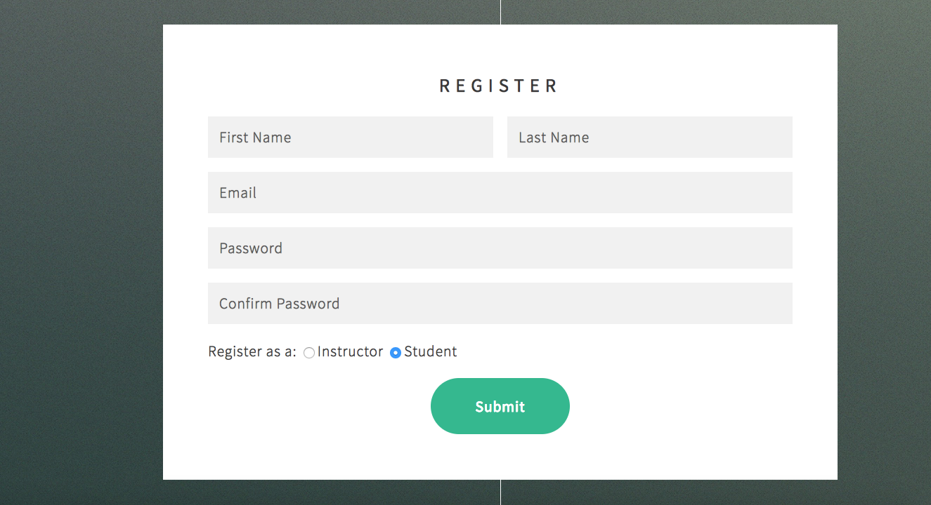

When the register button is clicked this is the page that should show up.

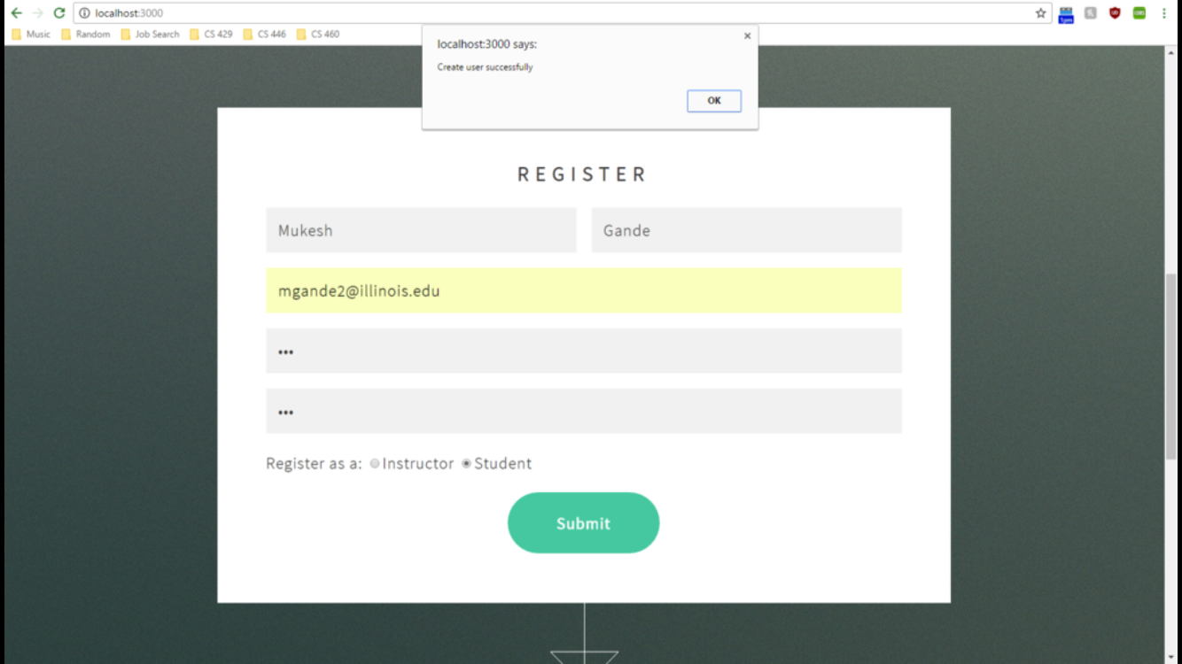When a user is created successfully a pop up box should be displayed notifying the user that the user has been created.

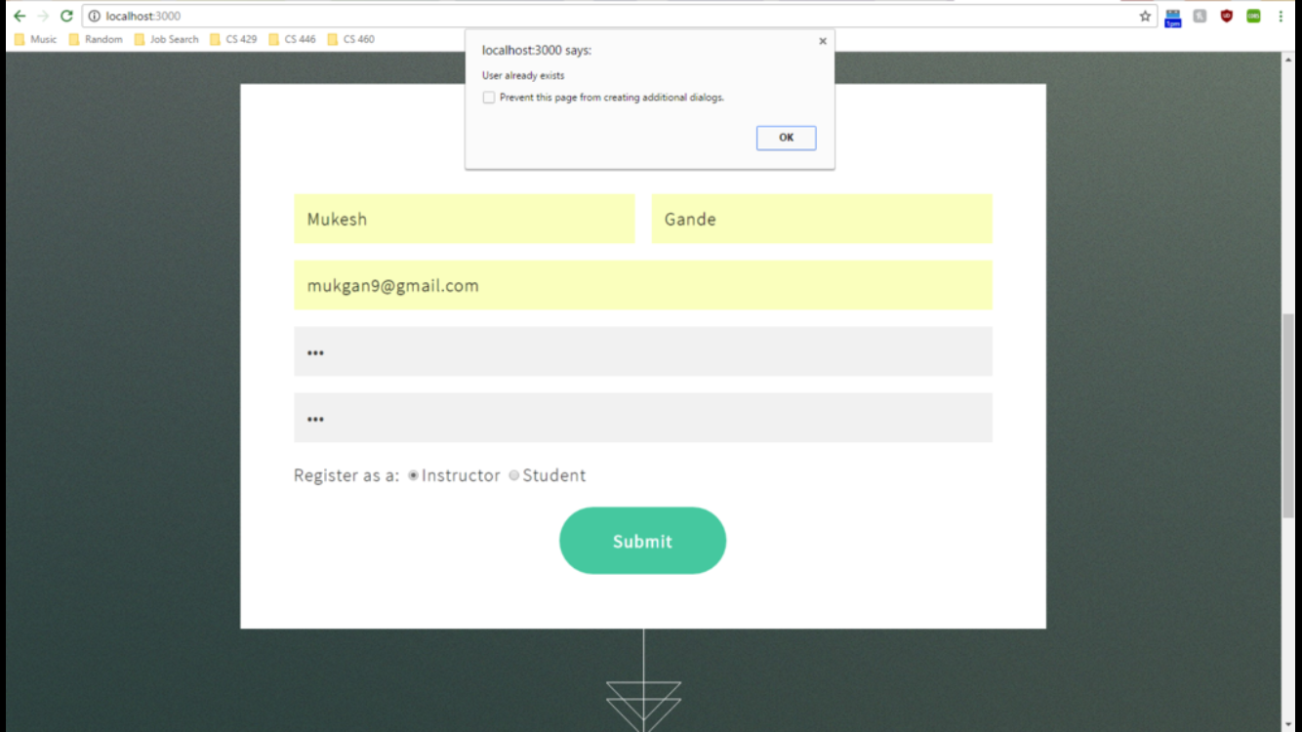

If the username/email already exists in the database, a pop up menu should appear notifying the user that the email is already registered.



When the user comes back to this page after submitting there information all the data should be cleared.